File → New → Project
Name: StudentRegistration
Click maven
Jdk:17 or click download jdk 17
Adavanced setting
com.example
click create
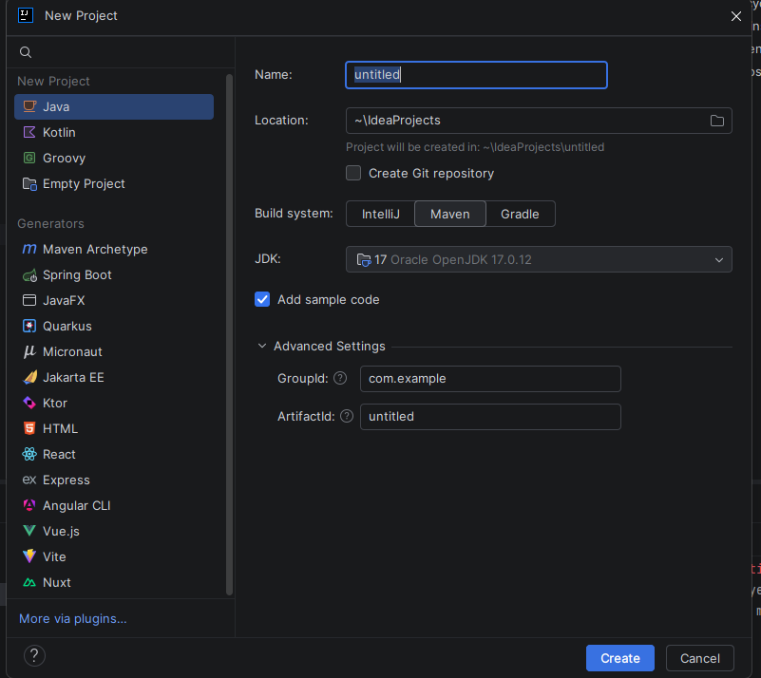
In pon .xml
Replace the code
<?xml version="1.0" encoding="UTF-8"?>

<project xmlns="http://maven.apache.org/POM/4.0.0"
xmlns:xsi="http://www.w3.org/2001/XMLSchema-instance"
xsi:schemaLocation="
http://maven.apache.org/POM/4.0.0
https://maven.apache.org/xsd/maven-4.0.0.xsd">

<modelVersion>4.0.0</modelVersion>

<!-- Project Information -->
<groupId>com.example</groupId>
<artifactId>StudentRegistration</artifactId>
<version>1.0-SNAPSHOT</version>

<!-- Create WAR file for Tomcat -->
<packaging>war</packaging>

<!-- Java 17 -->
<properties>
<maven.compiler.source>17</maven.compiler.source>
<maven.compiler.target>17</maven.compiler.target>
<project.build.sourceEncoding>UTF-8</project.build.sourceEncoding>
</properties>

<dependencies>

<!-- ===================================== -->
<!-- Jakarta Faces / JSF -->
<!-- ===================================== -->
<dependency>
<groupId>org.glassfish</groupId>
<artifactId>jakarta.faces</artifactId>
<version>4.0.5</version>
</dependency>

<!-- ===================================== -->
<!-- Jakarta Servlet API -->
<!-- Tomcat 10.1 provides Servlet 6.0 -->
<!-- ===================================== -->
<dependency>
<groupId>jakarta.servlet</groupId>
<artifactId>jakarta.servlet-api</artifactId>
<version>6.0.0</version>
<scope>provided</scope>
</dependency>

<!-- ===================================== -->
<!-- CDI API -->
<!-- ===================================== -->
<dependency>
<groupId>jakarta.enterprise</groupId>
<artifactId>jakarta.enterprise.cdi-api</artifactId>
<version>4.0.1</version>
</dependency>

<!-- ===================================== -->
<!-- Weld CDI implementation for Tomcat -->
<!-- ===================================== -->
<dependency>
<groupId>org.jboss.weld.servlet</groupId>
<artifactId>weld-servlet-core</artifactId>
<version>5.1.7.Final</version>
</dependency>

<!-- ===================================== -->
<!-- Jakarta Expression Language -->
<!-- ===================================== -->
<dependency>
<groupId>jakarta.el</groupId>
<artifactId>jakarta.el-api</artifactId>
<version>5.0.1</version>
</dependency>

<!-- ===================================== -->
<!-- Expression Language implementation -->
<!-- ===================================== -->
<dependency>
<groupId>org.glassfish</groupId>
<artifactId>jakarta.el</artifactId>
<version>5.0.0-M1</version>
</dependency>

<!-- ===================================== -->
<!-- Jakarta Annotation API -->
<!-- ===================================== -->
<dependency>
<groupId>jakarta.annotation</groupId>
<artifactId>jakarta.annotation-api</artifactId>
<version>2.1.1</version>
</dependency>

<!-- ===================================== -->
<!-- Jakarta Validation API -->
<!-- ===================================== -->
<dependency>
<groupId>jakarta.validation</groupId>
<artifactId>jakarta.validation-api</artifactId>
<version>3.0.2</version>
</dependency>

</dependencies>

<!-- ========================================= -->
<!-- BUILD -->
<!-- ========================================= -->

<build>

<finalName>StudentRegistration</finalName>

<plugins>

<!-- Maven Compiler -->
<plugin>
<groupId>org.apache.maven.plugins</groupId>
<artifactId>maven-compiler-plugin</artifactId>
<version>3.13.0</version>

<configuration>
<source>17</source>
<target>17</target>
</configuration>
</plugin>

<!-- WAR Plugin -->
<plugin>
<groupId>org.apache.maven.plugins</groupId>
<artifactId>maven-war-plugin</artifactId>
<version>3.4.0</version>

<configuration>
<failOnMissingWebXml>false</failOnMissingWebXml>
</configuration>
</plugin>

</plugins>

</build>

</project>

Once pom.xml is done on the right side maven logo will be there under the project click reload maven project
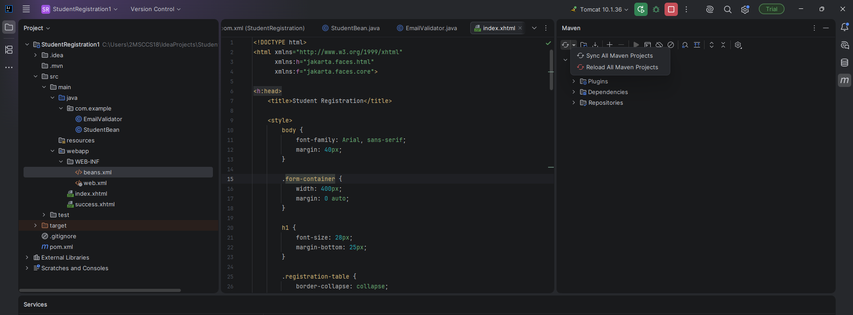

Right-click:
com.example
Choose:
New → Java Class
Enter:
StudentBean

package com.example;

import jakarta.inject.Named;
import jakarta.enterprise.context.SessionScoped;
import jakarta.faces.application.FacesMessage;
import jakarta.faces.context.FacesContext;

import java.io.Serializable;

@Named
@SessionScoped
public class StudentBean implements Serializable {

private String name;
private String email;

public String getName() {
return name;
}

public void setName(String name) {
this.name = name;
}

public String getEmail() {
return email;
}

public void setEmail(String email) {
this.email = email;
}

public String register() {

FacesContext context =
FacesContext.getCurrentInstance();

context.addMessage(
null,
new FacesMessage(
"Success",
"Student " + name +
" registered successfully!"
)
);

System.out.println("Student Name: " + name);
System.out.println("Student Email: " + email);

return "success";
}
}
Right-click:
com.example
Choose:
New → Java Class
Name:
EmailValidator

package com.example;

import jakarta.faces.application.FacesMessage;
import jakarta.faces.component.UIComponent;
import jakarta.faces.context.FacesContext;
import jakarta.faces.validator.Validator;
import jakarta.faces.validator.ValidatorException;
import jakarta.faces.validator.FacesValidator;

@FacesValidator("emailValidator")
public class EmailValidator implements Validator<Object> {

@Override
public void validate(
FacesContext context,
UIComponent component,
Object value)
throws ValidatorException {

if (value == null) {
return;
}

String email = value.toString();

String regex =
"^[\\w.%+-]+@[\\w.-]+\\.[A-Za-z]{2,6}$";

System.out.println(
"Entering into Email Validate: " + email
);

if (!email.matches(regex)) {

FacesMessage msg =
new FacesMessage(
"Invalid email format",
"Please enter a valid email address."
);

msg.setSeverity(
FacesMessage.SEVERITY_ERROR
);

throw new ValidatorException(msg);
}
}
}
src
→ main
Right-click main.
Choose:
New → Directory
Create:
webapp

Inside:
webapp
Right-click:
New → File
Name:
index.xhtml

<!DOCTYPE html>
<html xmlns="http://www.w3.org/1999/xhtml"
xmlns:h="jakarta.faces.html"
xmlns:f="jakarta.faces.core">

<h:head>
<title>Student Registration</title>

<style>
body {
font-family: Arial, sans-serif;
margin: 40px;
}

.form-container {
width: 400px;
margin: 0 auto;
}

h1 {
font-size: 28px;
margin-bottom: 25px;
}

.registration-table {
border-collapse: collapse;
}

.registration-table td {
border: 1px solid #ddd;
padding: 12px;
}

.label {
width: 100px;
font-size: 16px;
}

.input {
width: 220px;
height: 32px;
padding: 5px;
box-sizing: border-box;
}

.button-row {
padding-top: 15px !important;
border: none !important;
}

.register-button {
background-color: #2196F3;
color: white;
border: none;
padding: 10px 20px;
font-size: 16px;
border-radius: 4px;
cursor: pointer;
}

.register-button:hover {
background-color: #1976D2;
}

.error {
color: red;
font-size: 13px;
}
</style>
</h:head>

<h:body>

<div class="form-container">

<h1>Student Registration Form</h1>

<h:form id="registrationForm">

<table class="registration-table">

<!-- NAME -->
<tr>
<td class="label">
<h:outputLabel for="name" value="Name: *"/>
</td>

<td>
<h:inputText id="name"
value="#{studentBean.name}"
styleClass="input"
required="true"
requiredMessage="Name is required"/>

<br/>

<h:message for="name"
styleClass="error"/>
</td>
</tr>

<!-- EMAIL -->
<tr>
<td class="label">
<h:outputLabel for="email" value="Email: *"/>
</td>

<td>
<h:inputText id="email"
value="#{studentBean.email}"
styleClass="input"
required="true"
requiredMessage="Email is required">

<f:validator validatorId="emailValidator"/>

</h:inputText>

<br/>

<h:message for="email"
styleClass="error"/>
</td>
</tr>

<!-- REGISTER BUTTON -->
<tr>
<td colspan="2" class="button-row">

<h:commandButton value="Register"
action="#{studentBean.register}"
styleClass="register-button"/>

</td>
</tr>

</table>

</h:form>

</div>

</h:body>
</html>
Inside:
src
→ main
→ webapp
create:
success.xhtml

<!DOCTYPE html>

<html xmlns="http://www.w3.org/1999/xhtml"
xmlns:h="jakarta.faces.html">

<h:head>

<title>Registration Success</title>

</h:head>

<h:body>

<h2>Registration Successful!</h2>

<p>
Thank you, #{studentBean.name}, for registering!
</p>

<p>
We've sent a confirmation to:
#{studentBean.email}
</p>

<h:link
value="Back to Form"
outcome="index"/>

</h:body>

</html>
Inside:
webapp
right-click.
Choose:
New → Directory
Create:
WEB-INF

Inside WEB-INF, create new file
web.xml

<?xml version="1.0" encoding="UTF-8"?>

<web-app xmlns="https://jakarta.ee/xml/ns/jakartaee"
xmlns:xsi="http://www.w3.org/2001/XMLSchema-instance"
xsi:schemaLocation="https://jakarta.ee/xml/ns/jakartaee
https://jakarta.ee/xml/ns/jakartaee/web-app_6_0.xsd"
version="6.0">

<servlet>

<servlet-name>Faces Servlet</servlet-name>

<servlet-class>
jakarta.faces.webapp.FacesServlet
</servlet-class>

<load-on-startup>1</load-on-startup>

</servlet>

<servlet-mapping>

<servlet-name>Faces Servlet</servlet-name>

<url-pattern>*.xhtml</url-pattern>

</servlet-mapping>

<welcome-file-list>

<welcome-file>index.xhtml</welcome-file>

</welcome-file-list>

</web-app>

beans.xml

<?xml version="1.0" encoding="UTF-8"?>

<beans xmlns="https://jakarta.ee/xml/ns/jakartaee"
xmlns:xsi="http://www.w3.org/2001/XMLSchema-instance"
xsi:schemaLocation="
https://jakarta.ee/xml/ns/jakartaee
https://jakarta.ee/xml/ns/jakartaee/beans_4_0.xsd"
version="4.0"
bean-discovery-mode="annotated">
</beans>

